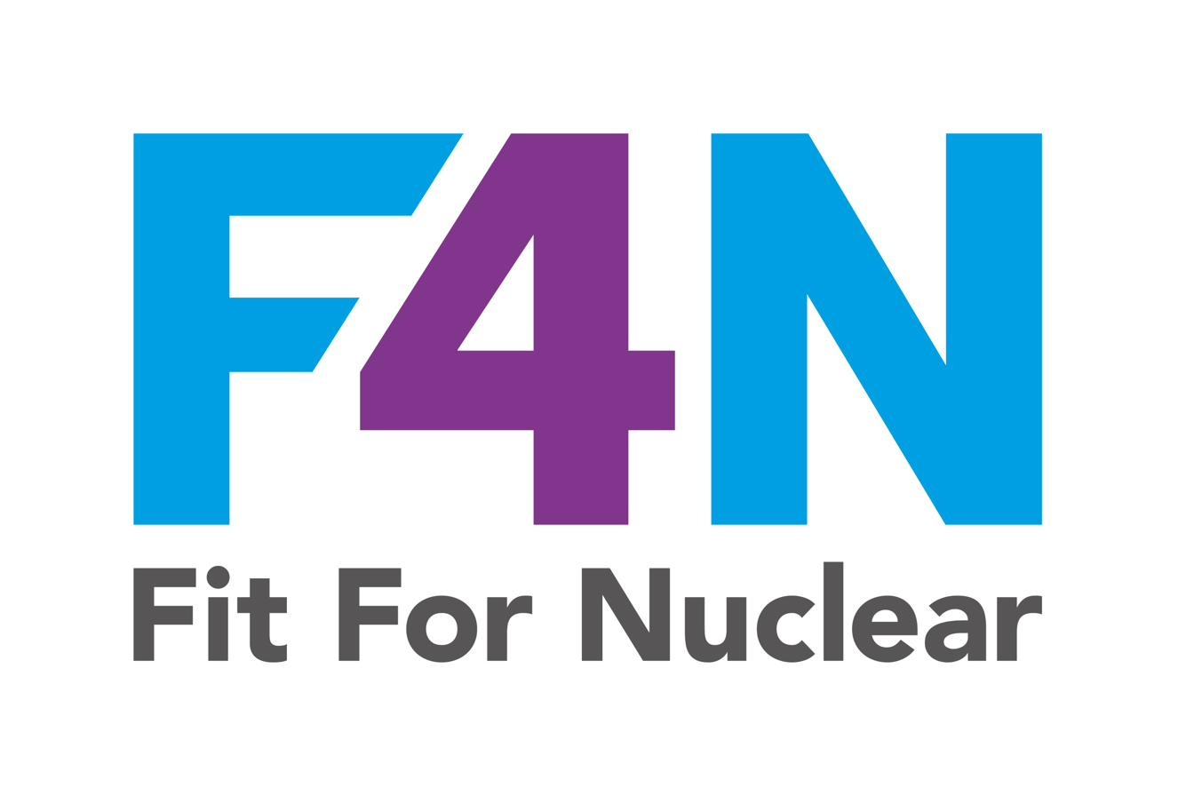
PRODUCTS & SERVICES STRATEGY
Process Excellence | PE-01a
[Company Name] | Version: | Date: | Owner:

HOW TO USE THIS DOCUMENT

This template is designed to be completed by the Senior Leadership Team (SLT) and should be owned by the Managing Director or Operations Director. It is a working strategy document, not a marketing document. It should be honest, specific, and directly connected to the day-to-day running of the business.

Complete each section in turn. Where example text is shown in italics, replace it with content specific to your organisation. The strategy should be reviewed and updated at least quarterly, or whenever there is a significant change in market conditions, customer requirements, or business direction.

Why This Matters to Nuclear Customers
Nuclear tier-one customers and programme operators including EDF, Hinkley Point C, Sizewell C, and Rolls-Royce SMR, do not simply ask whether you can make the part. They ask whether your organisation has the capability, capacity, and strategic intent to perform reliably over the long term. A well-articulated Products & Services Strategy, backed by a credible investment plan, demonstrates that your leadership team understands where the business is going and has a concrete plan to get there. Without it, you risk being seen as reactive and opportunistic, which is the opposite of what nuclear customers require.

1. ORGANISATION OVERVIEW

Provide an honest summary of what the organisation does today. This is the baseline from which your strategy builds. Be specific, as vague descriptions undermine credibility.

Company name
Year established
Primary products / services | Describe precisely what you make or deliver: materials, tolerances, batch sizes, finishes
Core manufacturing processes | e.g. CNC milling, turning, fabrication, welding, inspection, assembly, heat treatment
Key accreditations held | e.g. ISO 9001, AS9100, ISO 14001, ISO 45001, RISQS, Achilles. Include body and expiry date
Key customers (sectors) | e.g. aerospace OEMs, defence primes, oil & gas, automotive. No need to name specific customers
Approximate annual turnover (£)
Number of employees
Site area (sq ft / sq m)
Key equipment / capacity | List the 5–10 most significant machines or capabilities that define your capacity

2. MARKET POSITION & GROWTH OPPORTUNITY

This section defines the markets you are in today and where you intend to grow. The nuclear opportunity should be explicitly addressed here and should not be an afterthought. Nuclear customers want to see that you have thought seriously about the sector, understand its requirements, and have made a deliberate decision to pursue it.

Current market position | Summarise where you sit in your primary markets. Are you a tier-1, tier-2, or tier-3 supplier? What share do you hold? What is your reputation?
Primary growth targets | e.g. Nuclear new-build supply chain (Hinkley C, Sizewell C), SMR programme (Rolls-Royce), defence, aerospace
Nuclear opportunity | Describe specifically why nuclear is an attractive market for this business. Which components or services could you supply, to whom, and at what value?
Competitive advantages | What does this organisation do that competitors do not, or do less well? Be honest and include process capability, quality systems, lead times, specialised skills
Barriers to growth | What is currently preventing you from winning more business or entering new markets? Be candid about accreditation gaps, capacity constraints, skills shortages, cost base
Market risks | e.g. key customer dependency, pricing pressure, skills shortage, supply chain vulnerability, currency exposure

Example: Articulating the Nuclear Opportunity
A precision machining company might write: "We currently produce close-tolerance components for the aerospace sector to AS9100 Rev D. Our CNC turning and milling capabilities, including materials such as Inconel, duplex stainless, and titanium, are directly applicable to nuclear component manufacture. We have identified specific opportunities within the Hinkley Point C programme for reactor coolant system components and intend to qualify as a tier-2 supplier to [prime contractor] within 24 months. Our target contract value is £500k–£1.5m per annum." This is specific, credible, and investable, which is exactly what a nuclear customer wants to see.

3. STRATEGIC OBJECTIVES

Set out the organisation's top strategic objectives for the next 1–3 years. Each objective should be SMART: Specific, Measurable, Achievable, Relevant, and Time-bound. Avoid vague aspirations such as "grow the business" or "improve quality." These mean nothing without specificity.

Each objective should link directly to one or more of the investment and action items in sections 4–6 below. If an objective has no corresponding investment or action, it is an aspiration, not a strategy.

Ref | Strategic Objective | Measure of Success | Target Date | Owner
SO-01 | e.g. Achieve nuclear supply chain qualification (F4N) and secure first nuclear contract | e.g. F4N awarded; first PO received from nuclear customer | e.g. Q4 2025 | MD
SO-02 | e.g. Invest in additional CNC 5-axis machining capability to increase capacity by 30% | e.g. Machine installed and operational; capacity KPI achieved | e.g. Q2 2025 | Ops Director
SO-03 | e.g. Reduce cost of production by 12% through lean programme | e.g. Cost per unit reduced from £X to £Y | e.g. Dec 2025 | Production Manager
SO-04 | e.g. Progress AS9100 certification to unlock aerospace and defence growth | e.g. Stage 2 audit passed; certificate issued | e.g. Q3 2025 | Quality Manager
SO-05 | e.g. Develop workforce capability in nuclear-specific quality and traceability requirements | e.g. 100% of relevant staff trained; competence records current | e.g. Q1 2025 | HR / Ops Director
SO-06
SO-07

Common Mistake
Many companies list objectives that are actually business-as-usual activities such as "maintain ISO 9001 certification" or "keep health and safety compliant." These are not strategic objectives; they are operational requirements. Strategic objectives describe change, growth, and improvement. If your list of objectives looks like a maintenance schedule, revisit it.

4. INVESTMENT & CAPABILITY DEVELOPMENT PLAN

This section records the specific investments the organisation plans to make in people, equipment, technology, processes, or accreditations to deliver the strategic objectives. Every investment should be costed, owned, and time-bound.

Nuclear customers assess whether your investment plan is credible and funded. A strategy document that lists aspirational investments with no cost or timescale will not withstand scrutiny. Where investments are subject to funding decisions, note this clearly and provide the decision timeline.

Ref | Investment | Strategic Objective(s) | Estimated Cost (£) | Funding Source | Timescale | Owner | Status
INV-01 | e.g. 5-axis CNC machining centre | SO-02 | e.g. £280,000 | e.g. Bank finance | e.g. Q2 2025 | MD | e.g. Approved
INV-02 | e.g. AS9100 Rev D certification (consultancy + audit fees) | SO-04 | e.g. £18,000 | e.g. Internal | e.g. Q3 2025 | QM | e.g. In progress
INV-03 | e.g. Nuclear quality and traceability training (all production staff) | SO-05 | e.g. £6,500 | e.g. Internal | e.g. Q1 2025 | HR | e.g. Planned
INV-04 | e.g. ERP system upgrade to support traceability and job costing | SO-02, SO-03 | e.g. £45,000 | e.g. Internal / grant | e.g. Q4 2025 | MD | e.g. Under review
INV-05
INV-06

5. COST & PRODUCTIVITY IMPROVEMENT DRIVERS

Identify the key levers for cost reduction and productivity improvement within the business. These should be specific and measurable, not general statements. Each driver should link to a CSIP project (see PE-01b) and have a named owner responsible for delivery.

Nuclear customers expect their suppliers to have a demonstrable and disciplined approach to cost and efficiency. A business that cannot articulate how it controls and reduces its cost base will struggle to remain competitive on nuclear programmes, which typically demand long-term cost-down commitments.

Driver | Description | Current Baseline | Target | CSIP Project Ref | Owner
Labour efficiency | e.g. Reduce non-productive time through 5S and standard work | e.g. OEE 61% | e.g. OEE 75% | e.g. CSIP-04 | Ops Manager
Material waste | e.g. Reduce machining scrap rate through process control and SPC | e.g. 4.2% scrap | e.g. <2% | e.g. CSIP-07 | Quality Manager
Setup / changeover | e.g. Reduce setup time on CNC cells using SMED methodology | e.g. Avg 47 mins | e.g. <25 mins | e.g. CSIP-09 | Prod. Manager
Energy | e.g. Reduce energy cost per unit through shift pattern review and LED upgrade | e.g. £X/unit | e.g. £Y/unit (-15%) | e.g. CSIP-12 | Facilities
Overhead recovery | e.g. Improve machine utilisation to absorb fixed overhead more effectively | e.g. X% utilisation | e.g. Y% | e.g. CSIP-03 | Ops Director

6. KEY PERFORMANCE INDICATORS

The following KPIs will be used to measure performance against this strategy. KPIs should be visible on the shopfloor and discussed at every monthly performance review. If a KPI is not being actively discussed and acted upon, it is not being managed.

For each KPI, set a realistic baseline from actual recent performance data. Do not estimate or aspire. Targets should be stretching but achievable within the review period.

KPI | Definition | Baseline | Target | Review Frequency | Owner | Display Location
OEE % | Overall Equipment Effectiveness (Availability × Performance × Quality) |  |  | Weekly |  | Production board
OTIF % | On-time in-full delivery performance against customer confirmed dates |  |  | Weekly |  | Production board
Scrap / defect rate % | Percentage of output failing first-off or in-process inspection |  |  | Weekly |  | Quality board
Cost per unit (£) | Total manufacturing cost divided by units produced |  |  | Monthly |  | Management review
Labour productivity | Units or value produced per direct labour hour |  |  | Monthly |  | Management review
Customer complaints | Number of formal customer complaints received per month |  |  | Monthly |  | Quality board
CSIP completion rate % | Percentage of CSIP projects completed on time vs planned |  |  | Monthly |  | CSIP board / review

7. PRIORITY ACTIONS: 90-DAY PLAN

The 90-day plan translates the strategy into immediate, tangible actions. It is the bridge between strategic intent and operational delivery. This section should be updated at every quarterly strategy review.

Each action should be specific enough that at the next review you can clearly determine whether it has been completed or not. "Review the quality system" is not an action. "Complete gap analysis against ISO 19443 requirements and produce action plan by 31 March" is an action.

Ref | Action | Links to Objective | Owner | Due Date | Status | Notes / Evidence
A-01
A-02
A-03
A-04
A-05
A-06
A-07
A-08
A-09
A-10

8. REVIEW & GOVERNANCE

This strategy is a live document. It must be reviewed, challenged, and updated at regular intervals. A strategy that sits in a drawer and is never revisited is not a strategy, it is a wish list. Senior leadership must own this document and be prepared to discuss it in detail with their NucCol Supply Chain Consultant.

Review frequency | Quarterly as a minimum, or when triggered by a significant change in market conditions, customer requirements, or organisational capability
Review meeting format | SLT strategy review. Agenda item covering progress against objectives, KPI performance, investment status, and 90-day plan update
Document owner
Approved by
Date approved
Date of last review
Date of next review
Version number
Distribution | MD, Operations Director, Quality Manager, Finance Director, and any other SLT members. Not for distribution outside the organisation.

Review Date | Reviewed By | Key Changes Made | Version | Next Review Due

This document is issued for internal use only and is subject to the NucCol Commercial in Confidence policy. It should not be distributed outside the organisation without prior written consent from the document owner.

